**Generating HTML Reports in JMeter**

-- HTML Reports can be generated along with the test case running JMeter in Non-GUI mode or with the CSV generated after the test finishes

-- Case1:- **Running JMeter script in Non-GUI Mode-**

Hit the 3 pages as below with 20 Threads in Non-GUI Mode

**HomePage**-<https://lifecharger.org/>

**AboutPage**-<https://lifecharger.org/about/>

**ArchivePage**-<https://lifecharger.org/archives/>

--Go to the bin folder of the JMeter in the command line using below command (as per installed in your system path will change)

**cd C:/Users/ankit.cr.kumar/Desktop/JMeter/apache-jmeter-5.2.1/bin**

-- CSV file and result folder should be empty

-- **JMeter Scripts, Result file and Result Folder: -**

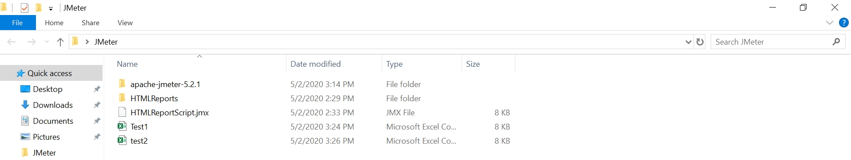

**jmeter -n -t "location of the jmeter script" -l "location of the result file" -e -o "location of the output folder"**

**jmeter -n -t C:/Users/ankit.cr.kumar/Desktop/JMeter/HTMLReportScript.jmx -l C:/Users/ankit.cr.kumar/Desktop/JMeter/test2.csv -e -o C:/Users/ankit.cr.kumar/Desktop/JMeter/HTMLReports/**

**--**Above commands was throwing below errors-

**Error in NonGUIDriver java.lang.IllegalArgumentException: Results file:C:/Users/ankit.cr.kumar/Desktop/JMeter/csvreport/Report.csv is not empty**

**An error occurred: Error in NonGUIDriver Results file:C:/Users/ankit.cr.kumar/Desktop/JMeter/csvreport/Report.csv is not empty**

**errorlevel=1**

**-- Errors description**

<https://stackoverflow.com/questions/39543782/java-lang-illegalargumentexception-results-log-file-is-not-empty-error-showin>

**--** So, we need to run the below commands (just add -f)

**jmeter -n -t C:/Users/ankit.cr.kumar/Desktop/JMeter/HTMLReportScript.jmx -l C:/Users/ankit.cr.kumar/Desktop/JMeter/csvreport/Report.csv -f -e -o C:/Users/ankit.cr.kumar/Desktop/JMeter/HTMLReports/**

**Screenshots: -**

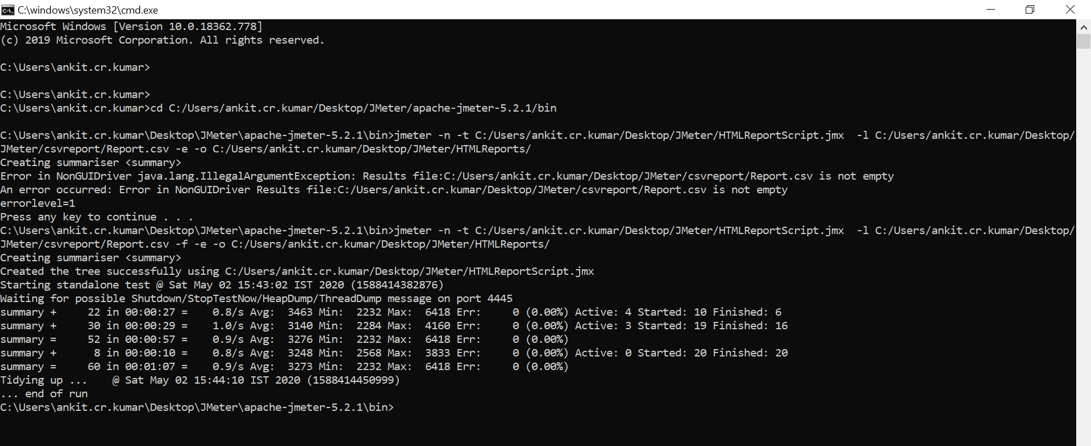

**--** HTMLReports folder has been generated, we need to click on **index.html** file

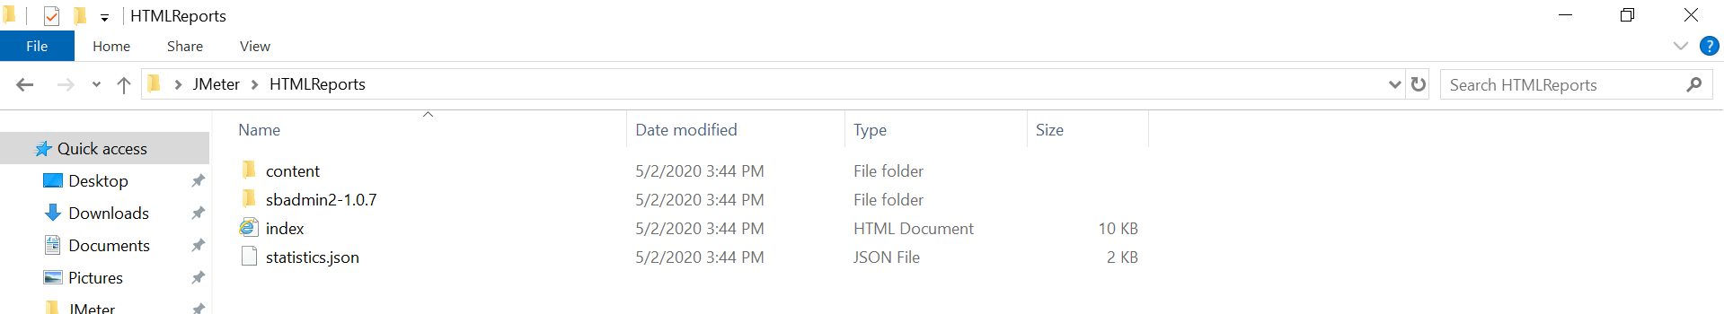

**--HTML Report**

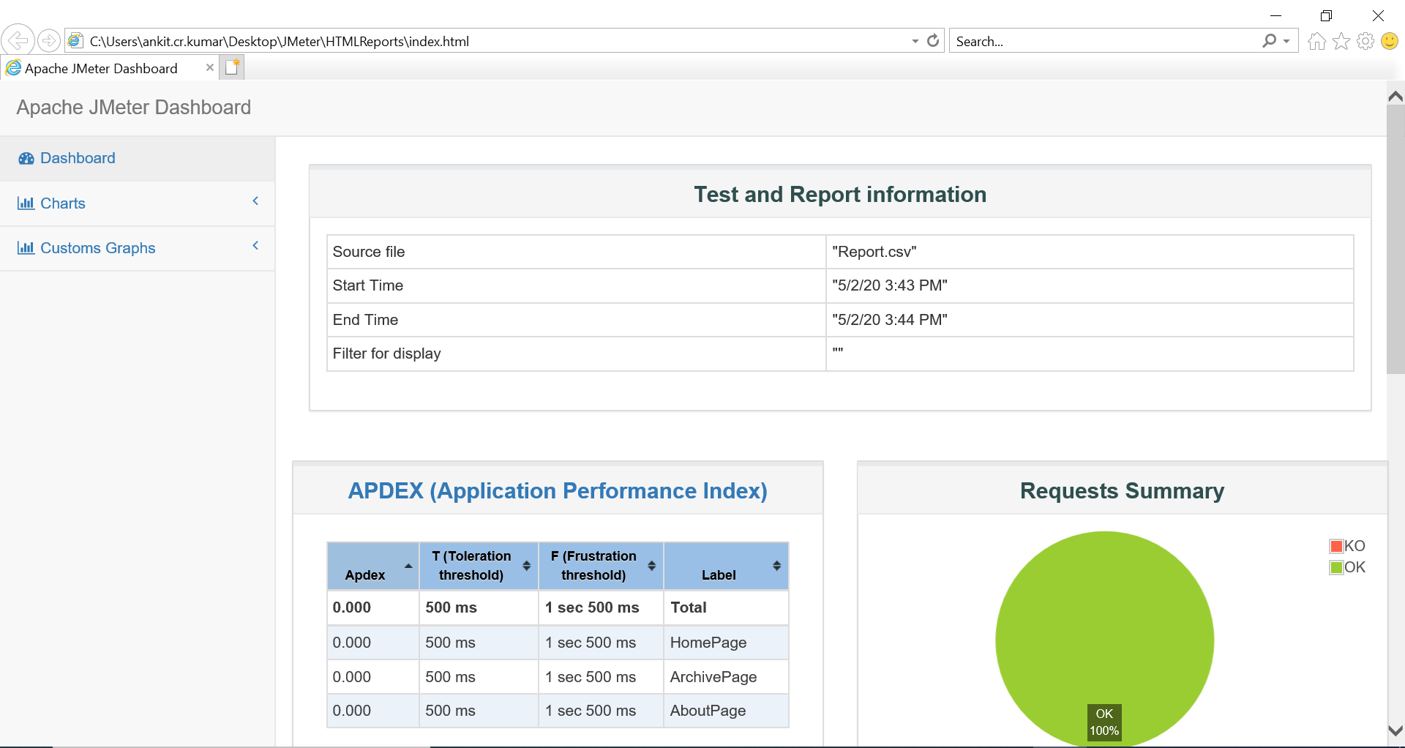

URL of HTML Report: - **C:\Users\ankit.cr.kumar\Desktop\JMeter\HTMLReports\index.html**

--**Generating HTML report from a CSV file-**

**--** TestResult File**=TESTRESULT.csv**

**--** Empty Folder Name**=CSVToHTML**

-- Create an empty folder and run below command in the command line

**jmeter -g C:\Users\ankit.cr.kumar\Desktop\BT\Others\JmeterPractice\TESTRESULT.csv -o C:\Users\ankit.cr.kumar\Desktop\BT\Others\JmeterPractice\CSVToHTML**

URL of HTML Report: - **C:\Users\ankit.cr.kumar\Desktop\BT\Others\JmeterPractice\CSVToHTML\index.html**

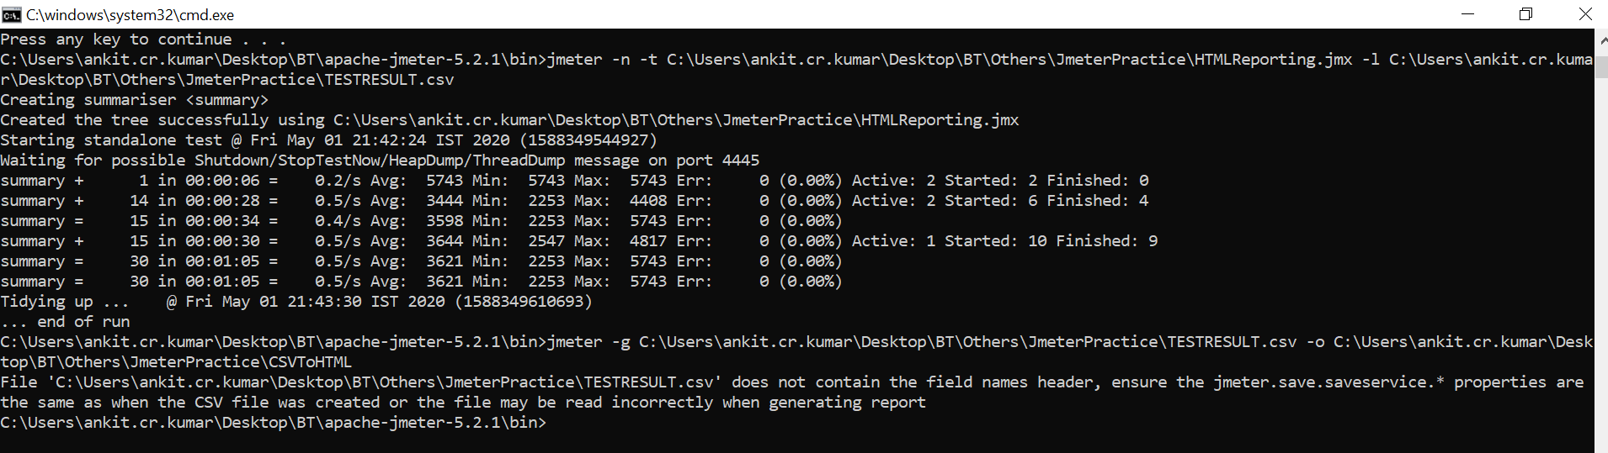

**CSV File: - TESTRESULT**

**Result Folder: -** Open **index.html** file and it will show the HTML Report.

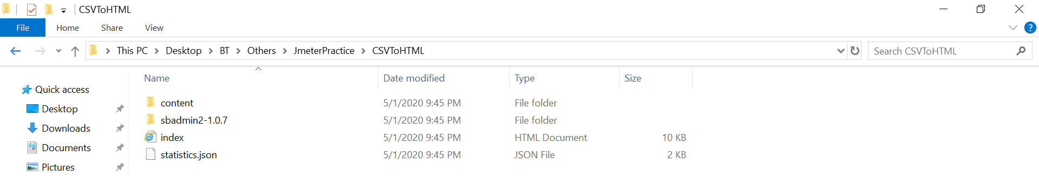

**HTML Report-**

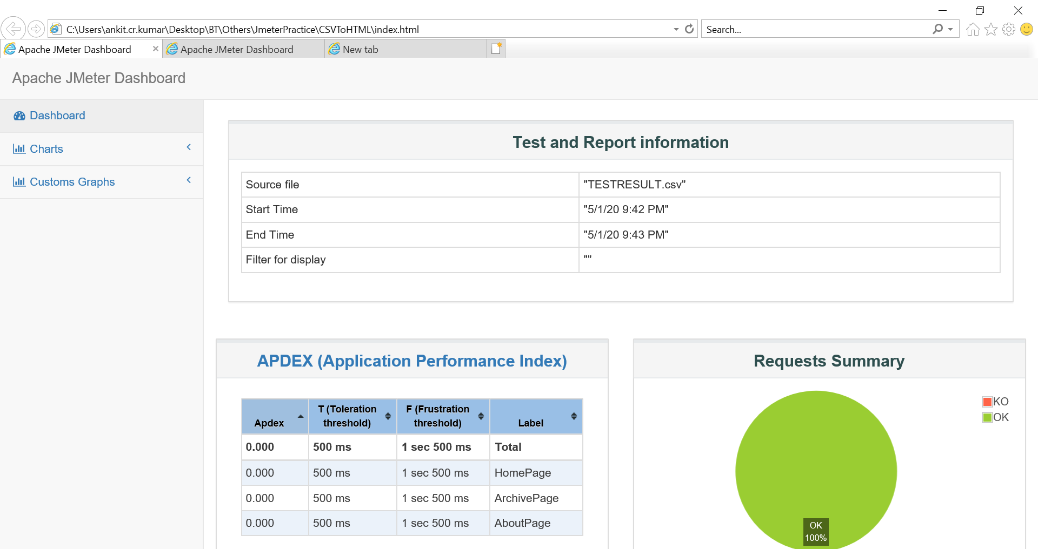

-- Important graph-

